Bug Report

ID number* | 41
Title* | Shopping cart icon on Single product page - the position is not in the top-right corner
Reporter* | Mădălina Dămoc
Submit Date | 03/05/2024
URL | https://www.saucedemo.com/
Platform | Windows
Operating System | Windows 10 Pro
Browser | Chrome Version 123.0.6312.86 (Official Build) (64-bit)
Severity* | S4
Assigned to | /
Priority* | P4

Description
In Single product page the shopping cart icon is not in the top-right corner, but slightly moved towards the center and a bit down.

Steps to reproduce
1. access site www.saucedemo.com in Chrome
2. insert valid data in field “Username” (visual_user)
3. insert valid data in field “Password” (secret_sauce)
4. press “Login” button
5. press image of one product

Expected result
In Single product page the shopping cart icon is in the top-right corner.

Actual result
In Single product page the shopping cart icon is not in the top-right corner, but slightly moved towards the center and a bit down (seems to be left-aligned with sort button).

Notes
The position of the shopping cart icon is the same (slightly moved towards the center and a bit down) in all pages: Home page, Single product page, Shopping cart page, Checkout page, Checkout overview page, Checkout complete page.

Actual result
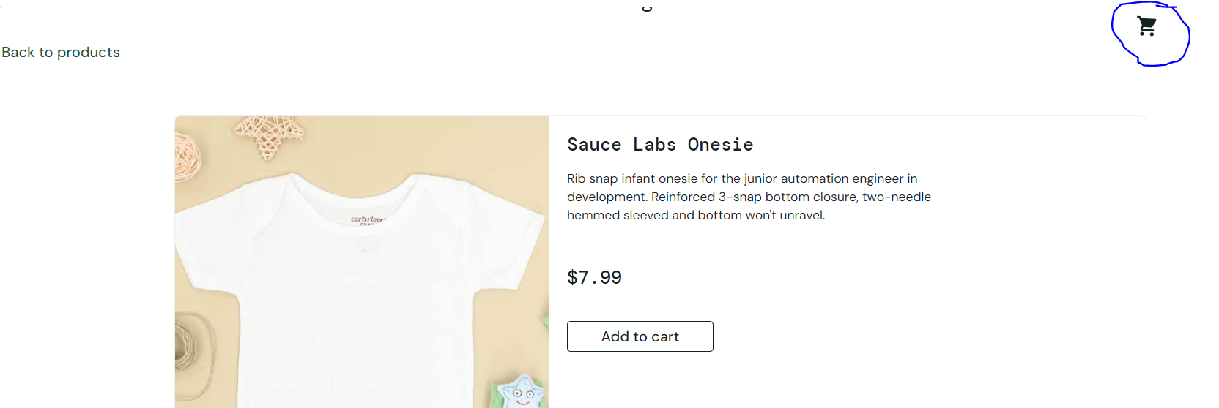
Expected result

